

**PENGARUH DAYA TARIK IKLAN TRAVELOKA “VERSI TRAVELING” DI TELEVISI TERHADAP *BRAND AWARENESS***

**(Survei Pada Komunitas Golden Rama, Kemang, Jakarta Selatan)**

**SKRIPSI**

**RISKA VANIYA PRAMESTI**

**121011411099**



**PENGARUH DAYA TARIK IKLAN TRAVELOKA “VERSI TRAVELING” DI TELEVISI TERHADAP *BRAND AWARENESS***

**(Survei Pada Komunitas Golden Rama, Kemang, Jakarta Selatan)**

**SKRIPSI**

**Diajukan Sebagai Salah Satu Syarat Untuk Memperoleh Gelar**

**Sarjana Ilmu Komunikasi**

**RISKA VANIYA PRAMESTI**

**1210411099**

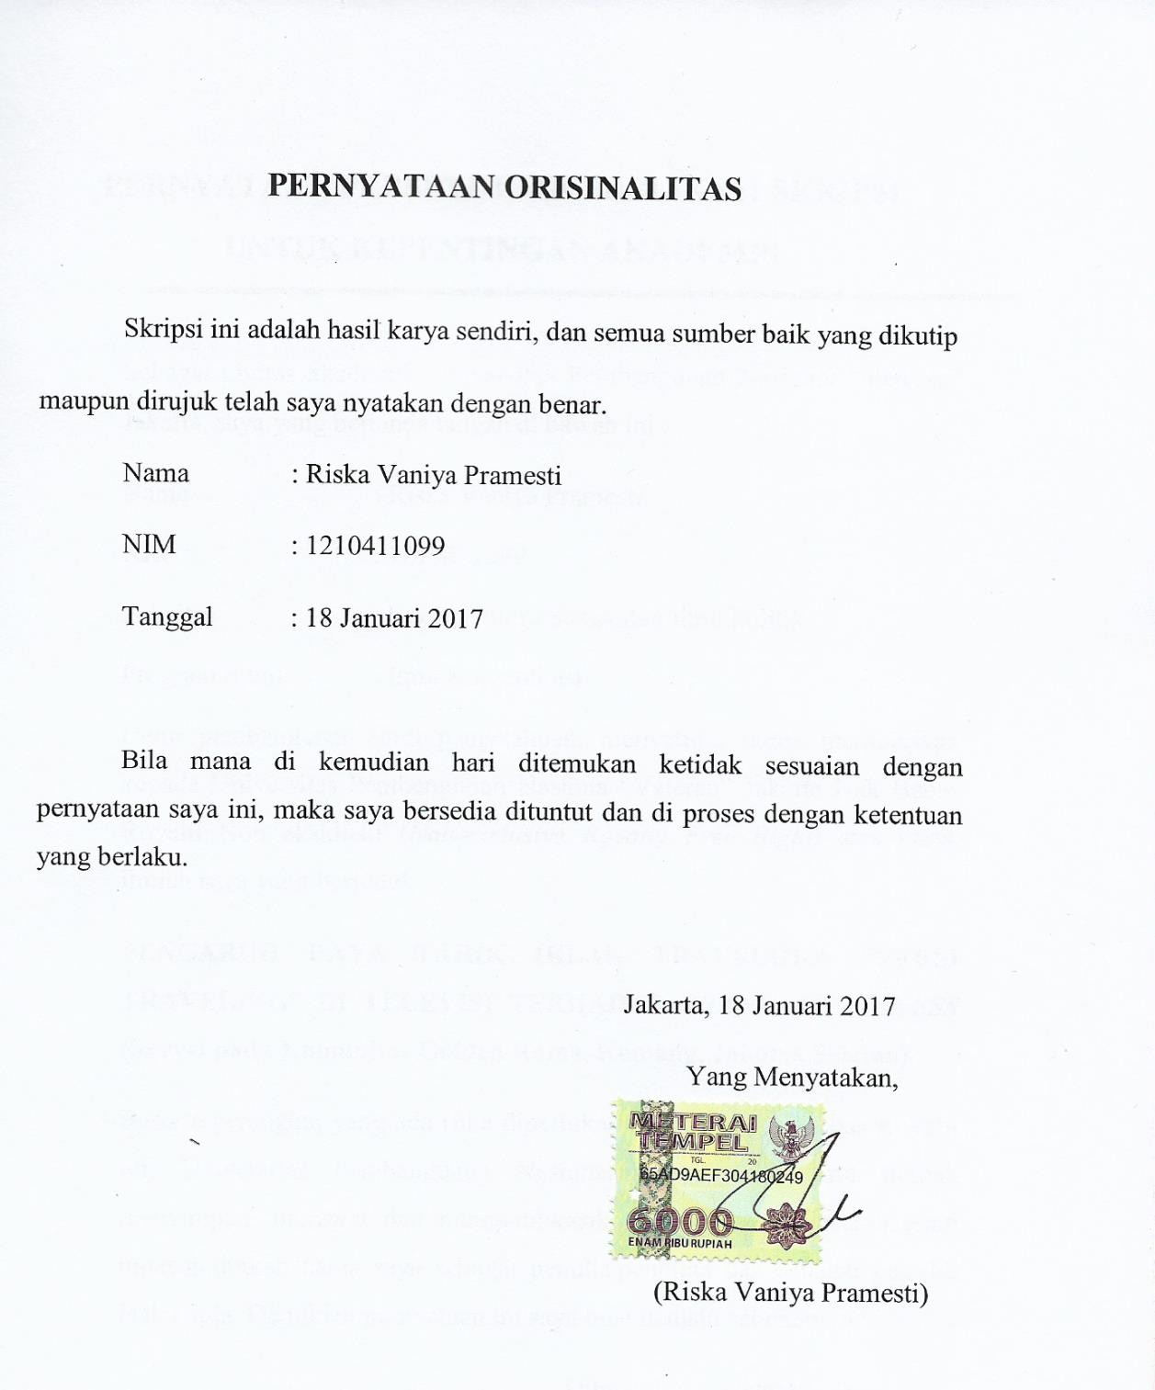

iii

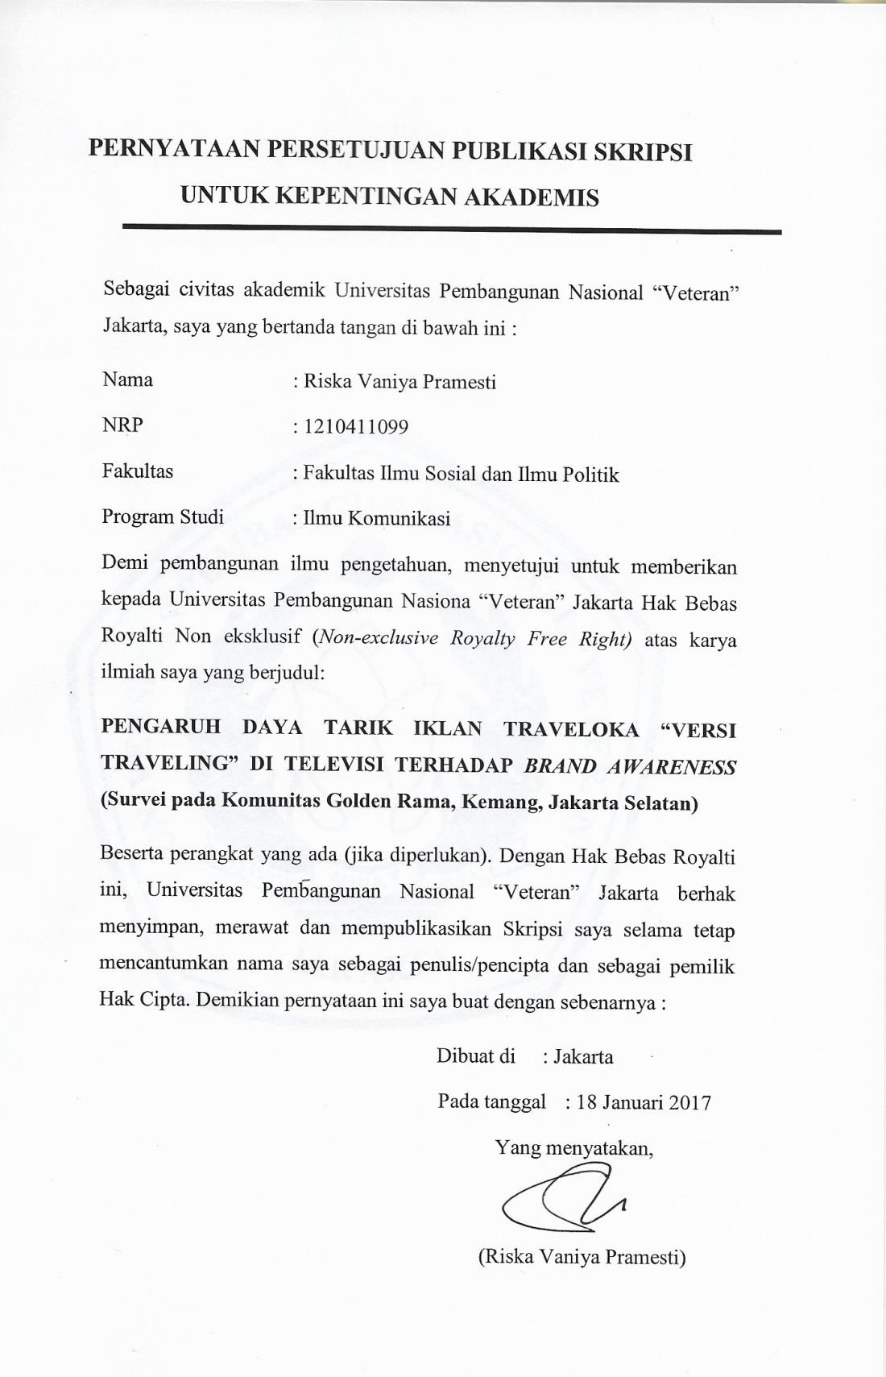

iv

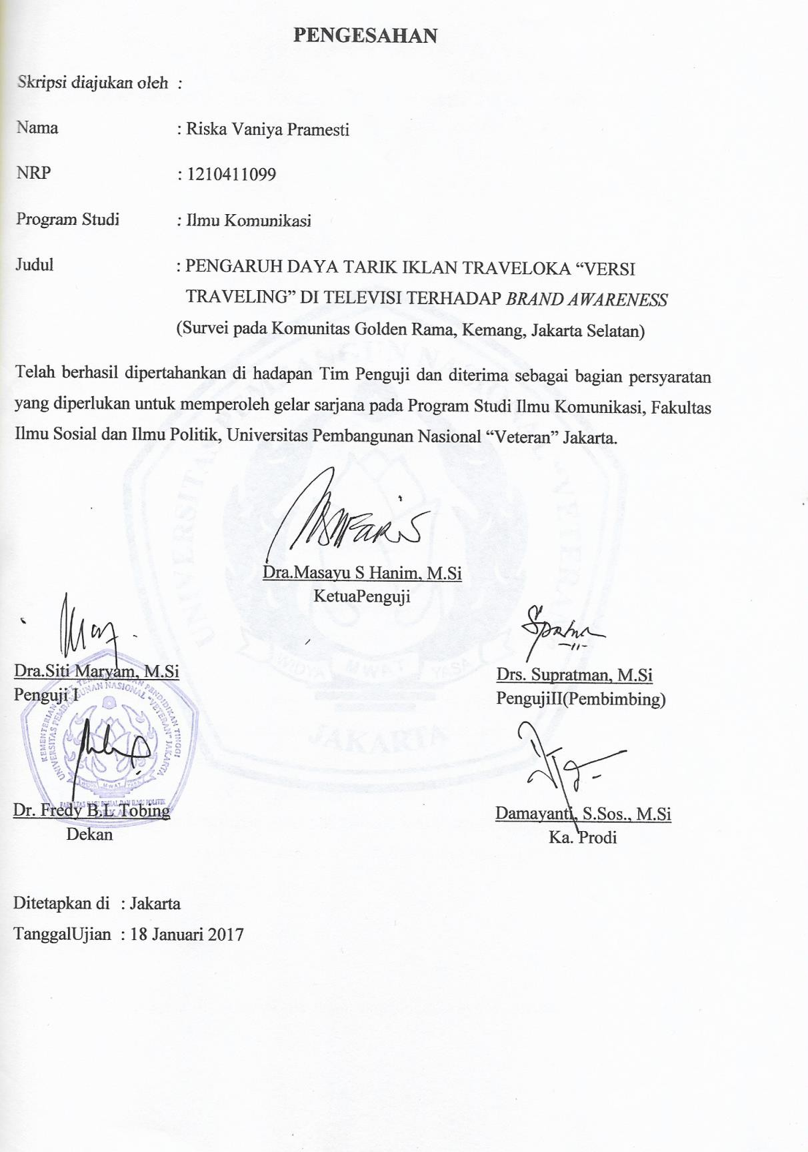

v

**Pengaruh Daya Tarik Iklan Traveloka Versi Travelling Di Televisi Terhadap *Brand Awareness* (Survei Pada Komunitas Golden Rama Kemang Jakarta Selatan)**

**Oleh**

**Riska Vaniya Pramesti**

**Abstrak**

Pada saat ini banyak masyarakat yang gemar melakukan traveling sendirian atau bersama keluarga, dengan begitu pula ada banyak persaingan antara perusahaan layanan online untuk menyediakan aplikasi yang menyediakan pembelian tiket transportasi secara online dan reservasi hotel. Traveloka adalah aplikasi yang dapat digunakan masyarakat dan memberi informasi yang disebarluaskan melalui media televisi. Dengan menggunakan daya tarik iklan traveloka melalui televisi yang ingin mengetahui seberapa kuat pengaruh daya tarik iklan traveloka versi traveling di televisi terhadap *brand awareness.* Teori yang digunakan dalam penelitian ini adalah daya tarik iklan dan *brand awareness.* Metode yang digunakan adalah kuantitatif, menggunakan kuesioner untuk pengumpulan data. Teknik sampling yang digunakan dalam penelitian ini adalah *accidental sampling.* Dalam penelitian ini menggunakan sampel sebesar 93 responden. Dari hasil uji korelasi terdapat pengaruh sebesar 0,811 yang menunjukkan bahwa daya tarik iklan traveloka versi traveling memiliki hubungan yang kuat terhadap *brand awareness.*

Kata Kunci : daya tarik iklan, traveloka, dan *brand awareness.*

**Influence The Attractiveness**

**Of Traveloka Version Travelling Advertising On Television Againt The Brand Awareness (Survey On The Community Of Golden Rama Kemang Jakarta Selatan)**

***By***

**Riska Vaniya Pramesti**

***Abstract***

*At this time many people are fond of doing travelling alone or with family, also there is a lot of competition between travel companies providing online services for application that provide transportation ticket purchase online and hotel reservation. Traveloka is an application that can be used in the community and give the information disserminated via television media advertising. By using of advertising through television, traveloka who want to give an impact on brand awareness. This research aims to know how stronge the influence of advertising appeal traveloka version of travelling on television againt the brand awareness. The theory used in this research is the appeal of advertising and brand awareness. The method used is quantitative, using questionnaires for data collection. The sampling techniques used in this research is accidental sampling. in this research using a sample of 93 the responden. The research result of correlation test from the influence is 0,811 which indicates that the people of traveloka advertisment travelling version have stronge relationship againt the brand awareness*

*Keywords : attraction advertisment, traveloka, and brand awareness*

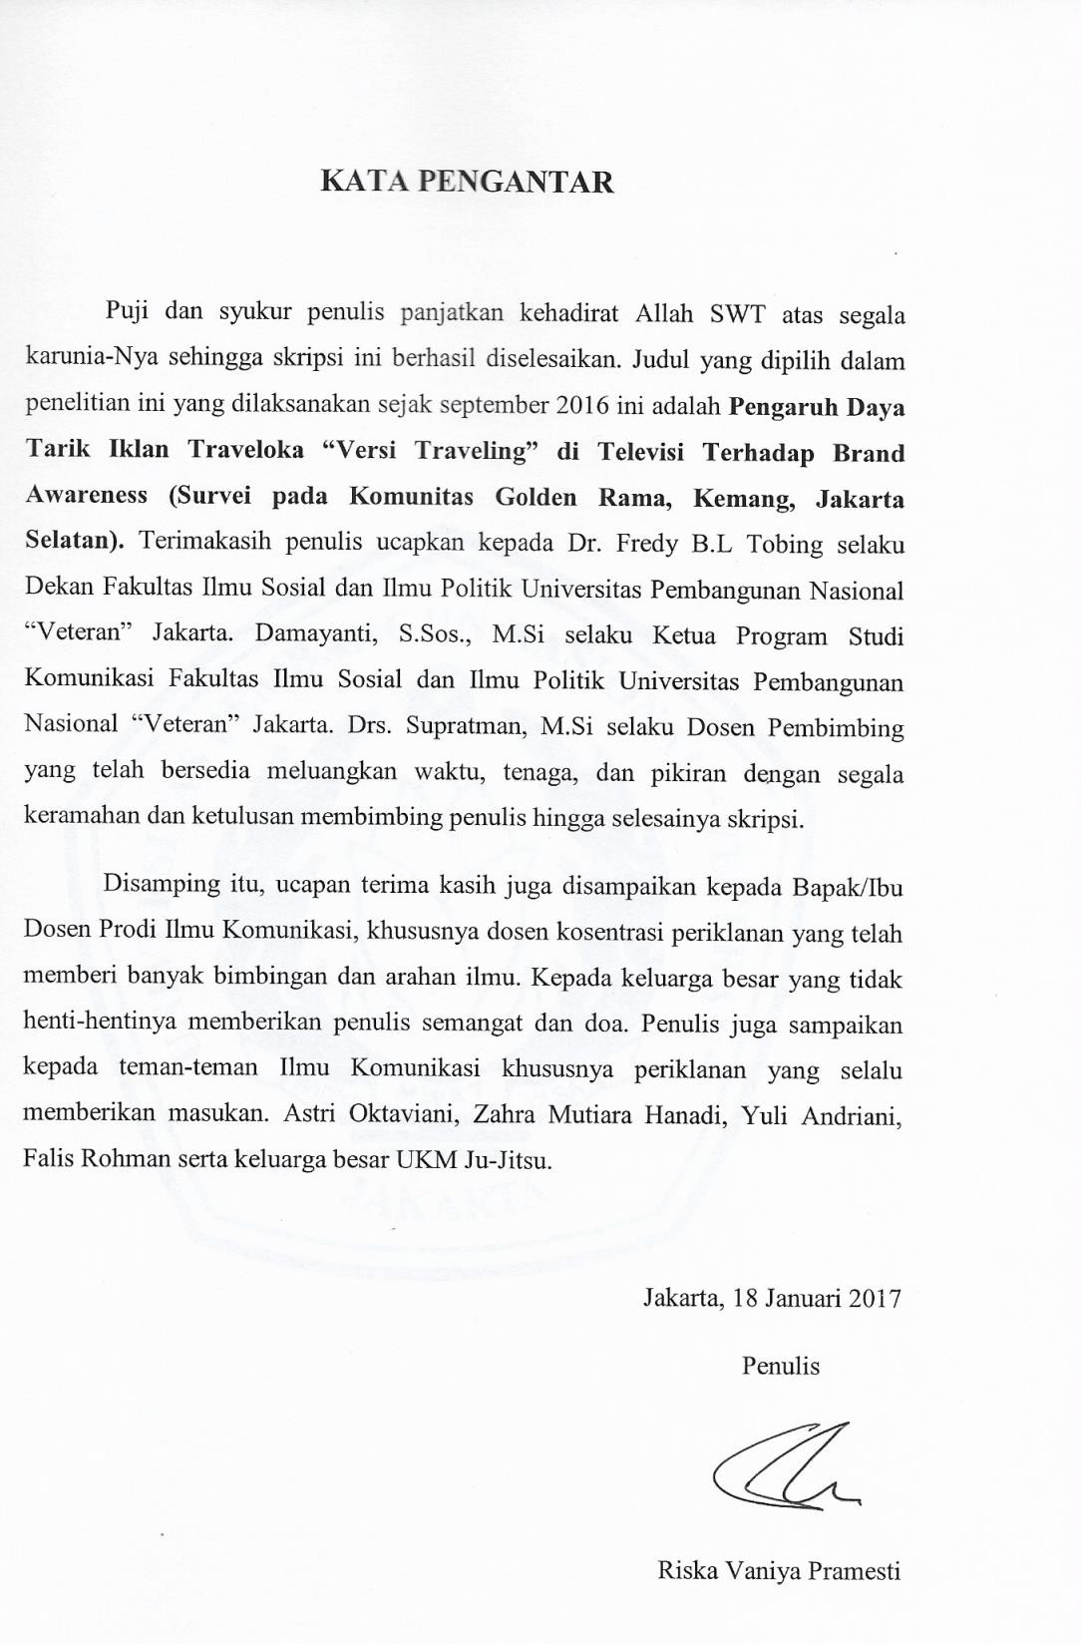

viii

**DAFTAR ISI**

**HALAMAN SAMPUL**................................................................................... i **HALAMAN JUDUL** ...................................................................................... ii **PERNYATAAN ORISINALITAS** ................................................................ iii **PERNYATAAN PERSETUJUAN PUBLIKASI**......................................... iv **PENGESAHAN** .............................................................................................. v **ABSTRAK** ...................................................................................................... vi ***ABSTRACT*** ..................................................................................................... vii **KATA PENGANTAR** .................................................................................... viii **DAFTAR ISI**................................................................................................... ix **DAFTAR TABEL** .......................................................................................... xi **DAFTAR GAMBAR** ...................................................................................... xii **DAFTAR LAMPIRAN** .................................................................................. xiii

|  |  |  |
| --- | --- | --- |
| **BAB I** | **PENDAHULUAN ..........................................................................** | **1** |
| I.1 | Latar Belakang................................................................................. | 1 |
| I.2 | Rumusan Masalah............................................................................ | 8 |
| I.3 | Tujuan Penelitian ............................................................................. | 8 |
| I.4 | Manfaat Penelitian ........................................................................... | 8 |
| I.5 | Sistematika Penulisan ...................................................................... | 9 |
| **BAB II** | **KERANGKA TEORI....................................................................** | **11** |
| II.1 | Komunikasi...................................................................................... | 11 |
| II.2 | Periklanan ........................................................................................ | 12 |
| II.3 | Televisi ............................................................................................ | 13 |
| II.4 | Komunikasi Massa .......................................................................... | 15 |
| II.5 | Daya Tarik Iklan .............................................................................. | 16 |
| II.6 | *Brand Awareness* ............................................................................. | 17 |
| II.6.1 | Tingkat *Brand Awareness* ............................................................... | 17 |
| II.7 | Kerangka Berpikir ........................................................................... | 19 |
| II.8 | Hipotesis .......................................................................................... | 19 |
| **BAB III** | **METEDOLOGI PENELITIAN ...................................................** | **21** |
| III.1 | Pendekatan Penelitian...................................................................... | 21 |
| III.2 | Jenis Penelitian ................................................................................ | 21 |
| III.3 | Metode Penelitian ............................................................................ | 21 |
| III.4 | Populasi Dan Sampel....................................................................... | 22 |
| III.4.1 | Populasi ........................................................................................... | 22 |
| III.4.2 | Sampel ............................................................................................. | 22 |
| III.5 | Teknik Sampling.............................................................................. | 23 |
| III.6 | Teknik Pengumpulan Data .............................................................. | 24 |
| III.6.1 | Data Primer...................................................................................... | 24 |
| III.6.2 | Data Sekunder.................................................................................. | 24 |
| III.7 | Operasional Variabel ....................................................................... | 25 |

|  |  |  |
| --- | --- | --- |
| III.8 | Teknik Analisis Data ....................................................................... | 26 |
| III.8.1 | Uji Validitas..................................................................................... | 26 |
| III.8.2 | Uji Reliabilitas ................................................................................. | 28 |
| III.8.3 | Uji Korelasi...................................................................................... | 30 |
| III.8.4 | Uji Determinasi................................................................................ | 30 |
| III.8.5 | Uji Regresi Linier Sederhana .......................................................... | 31 |
| III.8.6 | Uji Hipotesis .................................................................................... | 31 |
| III.9 | Waktu dan Tempat Penelitian.......................................................... | 32 |
| **BAB IV** | **HASIL PENELITIAN DAN PEMBAHASAN............................** | **33** |
| IV.1 | Profil Perusahaan PT.Traveloka Indonesia ..................................... | 33 |
| IV.2 | Karakteristik Responden.................................................................. | 35 |
| IV.3 | Analisis Deskriptif ........................................................................... | 37 |
| IV.4 | Uji Korelasi...................................................................................... | 53 |
| IV.5 | Uji Regresi ....................................................................................... | 54 |
| IV.6 | Uji Determinasi................................................................................ | 55 |
| IV.7 | Uji Hipotesis .................................................................................... | 56 |
| **BAB V** | **PENUTUP ......................................................................................** | **58** |
| V.1 | Kesimpulan ...................................................................................... | 58 |
| V.2 | Saran ................................................................................................ | 59 |

**DAFTAR PUSTAKA ..................................................................................... 61**

**RIWAYAT HIDUP LAMPIRAN**

**DAFTAR TABEL**

|  |  |  |
| --- | --- | --- |
| Tabel 1. | Skala Likert...................................................................................... | 24 |
| Tabel 2. | Operasional Variabel ....................................................................... | 25 |
| Tabel 3. | Uji Validitas Variabel X .................................................................. | 27 |
| Tabel 4. | Uji Validitas Variabel Y .................................................................. | 28 |
| Tabel 5. | Tingkat Reliabilitas.......................................................................... | 29 |
| Tabel 6. | Uji Reliabilitas Variabel X .............................................................. | 29 |
| Tabel 7. | Uji Realiabilitas Variabel Y ............................................................ | 30 |
| Tabel 8. | Tahapan Kegiatan Penelitian ........................................................... | 32 |
| Tabel 9. | Jenis Kelamin .................................................................................. | 35 |
| Tabel 10. | Usia Responden .............................................................................. | 36 |
| Tabel 11. | Responden Pernah Melihat Tayangan Iklan Traveloka .................. | 37 |
| Tabel 12. | Kuesioner X1 .................................................................................. | 37 |
| Tabel 13. | Kuesioner X2 .................................................................................. | 38 |
| Tabel 14. | Kuesioner X3 .................................................................................. | 39 |
| Tabel 15. | Kuesioner X4 .................................................................................. | 39 |
| Tabel 16. | Kuesioner X5 .................................................................................. | 40 |
| Tabel 17. | Kuesioner X6 .................................................................................. | 41 |
| Tabel 18. | Kuesioner X7 .................................................................................. | 42 |
| Tabel 19. | Kuesioner X8 .................................................................................. | 42 |
| Tabel 20. | Kuesioner X9 .................................................................................. | 43 |
| Tabel 21. | Kuesioner X10 ................................................................................ | 44 |
| Tabel 22. | Kuesioner X11 ................................................................................ | 44 |
| Tabel 23. | Kuesioner X12 ................................................................................ | 45 |
| Tabel 24. | Kuesioner Y1 .................................................................................. | 46 |
| Tabel 25. | Kuesioner Y2 .................................................................................. | 47 |
| Tabel 26. | Kuesioner Y3 .................................................................................. | 47 |
| Tabel 27. | Kuesioner Y4 .................................................................................. | 48 |
| Tabel 28. | Kuesioner Y5 .................................................................................. | 49 |
| Tabel 29. | Kuesioner Y6 .................................................................................. | 50 |
| Tabel 30. | Kuesioner Y7 .................................................................................. | 51 |
| Tabel 31. | Kuesioner Y8 .................................................................................. | 51 |
| Tabel 32. | Kuesioner Y9 .................................................................................. | 52 |
| Tabel 33. | Kuesioner Y10 ................................................................................ | 53 |
| Tabel 34. | Interval Koefisien............................................................................ | 53 |
| Tabel 35. | Uji Korelasi ..................................................................................... | 54 |
| Tabel 36. | Uji Regresi ...................................................................................... | 55 |
| Tabel 37. | Uji Determinasi ............................................................................... | 55 |

**DAFTAR GAMBAR**

|  |  |
| --- | --- |
| Gambar 1. Website Traveloka.......................................................................... | 2 |
| Gambar 2. Scene Logo Traveloka.................................................................... | 2 |
| Gambar 3. Scene Reservasi.............................................................................. | 3 |
| Gambar 4. Kelebihan Traveloka ...................................................................... | 3 |
| Gambar 5. Scene Akhir Iklan Traveloka.......................................................... | 4 |
| Gambar 6. Hasil Presentase.............................................................................. | 4 |
| Gambar 7. Tingkat *Brand Awareness* .............................................................. | 17 |
| Gambar 8. Kerangka Berpikir .......................................................................... | 19 |
| Gambar 9. Logo Traveloka .............................................................................. | 33 |
| Gambar 10.Website Traveloka......................................................................... | 34 |
| Gambar 11.Cara Pemesanan Tiket Pesawat dan Hotel .................................... | 34 |

**DAFTAR LAMPIRAN**

Lampiran 1 Form A.2.2 (Kegiatan Konsultasi Skripsi) Lampiran 2 Form A.5 (Tanda Persetujuan Ujian Skirpsi) Lampiran 3 Surat Permohonan Riset

Lampiran 4 Surat Keterangan Balasan Riset

Lampiran 5 Kartu Hasil Studi

Lampiran 6 *Fotocopy* Tes TOEFL

Lampiran 7 *Fotocopy* Transkip Pembayaran s.d Terakhir Lampiran 8 Surat Keterangan Bebas Pinjam Perpustakan Fakultas Lampiran 9 Fotokopi Ijazah SMA

Lampiran 10 Kuesioner

Lampiran 11 Hasil Uji dengan SPSS 21