MANAJEMEN RISIKO DAN MEDIA EXPOSURE
SEBAGAI PEMODERASI
PENGARUH CORPORATE SOCIAL RESPONSIBILITY
TERHADAP NILAI PERUSAHAAN HIGH PROFILE
DI INDONESIA

SKRIPSI

ROSIDA MAJID 1710112185

PROGRAM STUDI AKUNTANSI PROGRAM SARJANA
FAKULTAS EKONOMI DAN BISNIS
UNIVERSITAS PEMBANGUNAN NASIONAL VETERAN JAKARTA
2021

MANAJEMEN RISIKO DAN MEDIA EXPOSURE
SEBAGAI PEMODERASI
PENGARUH CORPORATE SOCIAL RESPONSIBILITY
TERHADAP NILAI PERUSAHAAN HIGH PROFILE
DI INDONESIA

SKRIPSI

ROSIDA MAJID 1710112185

PROGRAM STUDI AKUNTANSI PROGRAM SARJANA
FAKULTAS EKONOMI DAN BISNIS
UNIVERSITAS PEMBANGUNAN NASIONAL VETERAN JAKARTA
2021

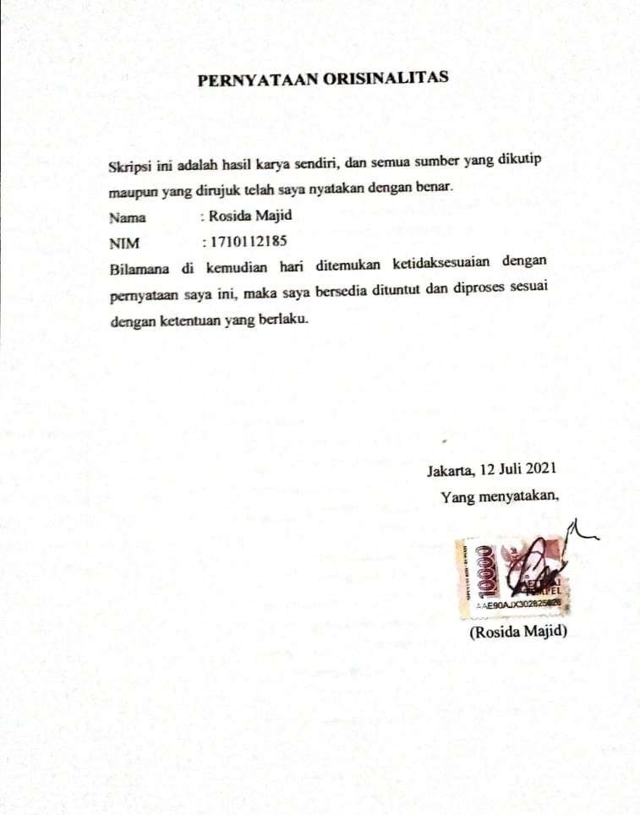

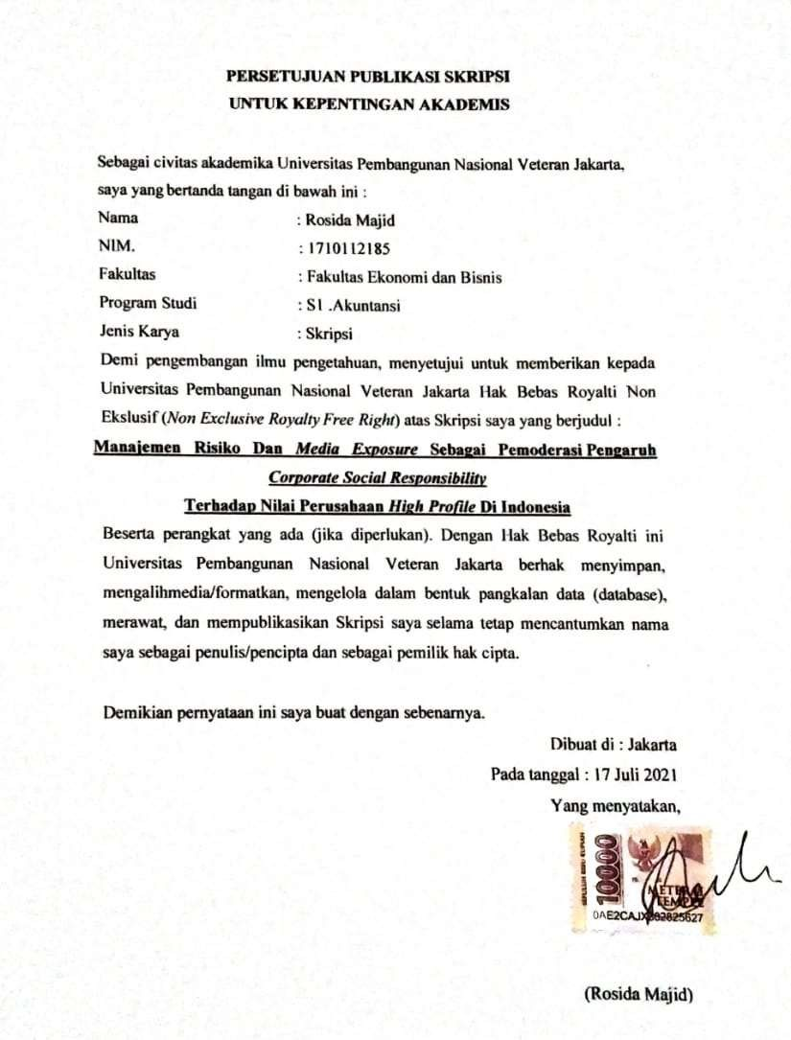

SKRIPSI

MANAJEMEN RISIKO DAN MEDIA EXPOSURE
SEBAGAI PEMODERASI
PENGARUH CORPORATE SOCIAL RESPONSIBILITY
TERHADAP NILAI PERUSAHAAN HIGH PROFILE DI INDONESIA

Dipersiapkan dan disusun oleh :
Rosida Majid 1710112185

Telah dipertahankan di depan Tim Penguji pada tanggal : 17 Juli 2021
dan dinyatakan memenuhi syarat untuk diterima

Praptiningsih, S.E., M.M.
Ketua Penguji
Ekawati Jati Wibawaningsih, S.A.,M.Acc.,Akt Aniek Wijayanti, S.E., M.Acc.

Penguji I Penguji II
Dr. Dianwicaksih Arieftiara, SE.,M.Ak.,Ak.,CA.,CSRS Andi Manggala Putra, S.E., M.Sc.

Dekan Fakultas Ketua Program Studi

Disahkan di : Jakarta
Pada tanggal : 17 Juli 2021

RISK MANAGEMENT AND MEDIA EXPOSURE AS MODERATOR THE INFLUENCE OF CORPORATE SOCIAL RESPONSIBILITY ON THE VALUE OF HIGH PROFILE COMPANIES IN INDONESIA

By Rosida Majid

Abstract

CSR information can give positive signal to its readers, especially investors in making investment decisions, thus affecting the value of the company. The application of appropriate risk management in the company's operational activities can minimize the possibility of failure of the company's activities including the company's CSR activities and provide added value for the company. The interest of high-profile companies to disclose their CSR activities is greater than that of lowprofile companies. Due to their high sensitivity to the company's external interests, high profile companies are not spared from the media. This study aims to obtain empirical evidence on the influence of CSR on the firm value of high profile companies in 2016-2018 along with risk management and media exposure as moderators of this influence. The research method used is a quantitative method with partial regression analysis techniques and moderation obtained from secondary data of 69 research samples. The results of the analysis state that there is a significant positive effect of CSR on the firm value of high profile companies. However, risk management and media exposure cannot moderate the effect of CSR on the firm value of high profile companies.

Keywords: Corporate Value, CSR, Risk Management, Media Exposure

MANAJEMEN RISIKO DAN MEDIA EXPOSURE
SEBAGAI PEMODERASI

PENGARUH CORPORATE SOCIAL RESPONSIBILITY TERHADAP NILAI PERUSAHAAN HIGH PROFILE DI INDONESIA

Oleh Rosida Majid

Abstrak

Informasi CSR dapat memberikan sinyal positif kepada pembacanya terutama para investor dalam pengambilan keputusan investasi sehingga mempengaruhi nilai perusahaan. Penerapan manajemen risiko yang tepat dalam aktivitas operasional perusahaan dapat menimalisir kemungkinan kegagalan aktivitas perusahaan termasuk aktivitas CSR perusahaan dan memberikan nilai tambah bagi perusahaan. Kepentingan perusahaan high profile untuk mengungkapkan aktivitas CSR mereka lebih besar dari perusahaan low profile. Dikarenakan sensitivitasnya yang tinggi terhadap kepentingan eksternal perusahaan, perusahaan high profile tidak luput dari media. Penelitian ini bertujuan untuk mendapatkan bukti empiris atas pengaruh CSR terhadap nilai perusahaan high profile tahun 2016-2018 beserta manajemen risiko dan media exposure sebagai pemoderasi pengaruh tersebut. Metode penelitian yang digunakan adalah metode kuantitatif dengan teknik analisis regresi parsial dan moderasi yang diperoleh dari data sekunder perusahaan atas 69 sampel penelitian. Hasil analisis menyatakan terdapat pengaruh positif signifikan CSR terhadap nilai perusahaan high profile. Namun, manajemen risiko dan media exposure tidak dapat memoderasi pengaruh CSR terhadap nilai perusahaan high profile.

Kata Kunci: Nilai Perusahaan, CSR, Manajemen Risiko, Media Exposure

KEMENTERIAN PENDIDIKAN, KEBUDAYAAN, RISET, DAN TEKONOLOGI
UNIVERSITAS PEMBANGUNAN NASIONAL VETERAN JAKARTA FAKULTAS EKONOMI DAN BISNIS
Jalan Rumah Sakit Fatmawati, Pondok Labu, Jakarta Selatan 12450
Telepon 021-7656971, Fax 021-7656904
laman : www.feb.upnvj.ac.id , e-mail : febupnvj@upnvj.ac.id

BERITA ACARA UJIAN SKRIPSI
SEMESTER GENAP TA. 2020/2021

Pada hari ini Sabtu, tanggal 17 Juli 2021, telah dilaksanakan Ujian Skripsi bagi mahasiswa :
Nama : Rosida Majid
Nomor Induk Mahasiswa : 1710112185
Program Studi : S1 Akuntansi

“MANAJEMEN RISIKO DAN MEDIA EXPOSURE SEBAGAI PEMODERASI PENGARUH CORPORATE SOCIAL RESPONSIBILITY TERHADAP NILAI PERUSAHAAN HIGH PROFILE DI INDONESIA“
Dinyatakan yang bersangkutan Lulus / Tidak Lulus *)

Tim Penguji
No | Dosen Penguji | Jabatan | Tanda Tangan
1 | Praptiningsih, S.E., M.M. | Ketua | 1
2 | Ekawati Jati Wibawaningsih, S.A.,M.Acc.,Akt | Anggota I | 2
3 | Aniek Wijayanti S.E., M.Acc. | Anggota II**) | 3
Catatan :
*) Coret yang tidak perlu
**) Dosen Pembimbing
JAKARTA, 17 Juli 2021
MENGESAHKAN
A.n. Dekan Kaprogdi Andi Manggala Putra, S.E., M.Sc.
PRAKATA

Puji dan syukur penulis panjatkan kepada Tuhan Yang Maha Esa atas segala karunia-Nya sehingga usulan penelitian ini berhasil diselesaikan. Penelitian ini dilaksanakan sejak bulan Februari sampai dengan Juli 2021 dengan judul ” Manajemen Risiko dan Media Exposure sebagai Pemoderasi Pengaruh Corporate Social Responsibility terhadap Nilai Perusahaan High Profile di Indonesia”. Pada kesempatan ini penulis menyampaikan terima kasih kepada Ibu Aniek Wijayanti, S.E., M.Acc. selaku Dosen Pembimbing I dan Ibu Ranti Nugraheni S.Si., M.S.Ak. selaku Dosen Pembimbing II yang telah banyak memberikan arahan dan saransaran yang sangat bermanfaat. Di samping itu, ucapan terima kasih juga disampaikan kepada Ayah dan Ibu serta seluruh keluarga yang tidak henti-hentinya memberikan semangat dan doa kepada penulis. Penulis juga menyampaikan terima kasih kepada seseorang yang telah dengan sabar mendengarkan segala keluh kesah penulis serta teman- teman yang telah membantu dalam penulisan usulan penelitian ini. Semoga usulan penelitian ini bermanfaat.

Jakarta, 17 Juli 2021

Rosida Majid

DAFTAR ISI

HALAMAN JUDUL ............................................................................................. ii PERNYATAAN ORISINALITAS ........................................................................ iii
PERSETUJUAN PUBLIKASI SKRIPSI
UNTUK KEPENTINGAN AKADEMIS ............................................................ iv HALAMAN PENGESAHAN ............................................................................ v ABSTRACT ......................................................................................................... vi ABSTRAK............................................................................................................ vii
BERITA CARA UJIAN SKRIPSI ...................................................................... viii
PRAKARTA ....................................................................................................... ix DAFTAR ISI ........................................................................................................ x
DAFTAR TABEL .............................................................................................. xiv DAFTAR GAMBAR/GRAFIK ......................................................................... xv DAFTAR LAMPIRAN ...................................................................................... xvi
BAB I PENDAHULUAN .................................................................................... 1
I.1 Latar Belakang ................................................................................................ 1
I.2 Perumusan Masalah ......................................................................................... 8
I.3 Tujuan Penelitian ............................................................................................. 8
I.4 Manfaat Penelitian ........................................................................................... 9
I.4.1 Aspek Teoritis ............................................................................................... 9
I.4.2 Aspek Praktis ................................................................................................ 9
BAB II TINJAUAN PUSTAKA ......................................................................... 10 II.1 Landasan Teori ............................................................................................. 10 II.1.1 Teori Stakeholder (Pemangku Kepentingan) ............................................ 10 II.1.2 Teori Signal ............................................................................................... 11 II.1.3 Teori Legitimasi ........................................................................................ 13 II.1.4 Perusahaan High Profile ............................................................................ 13 II.1.5 Nilai Perusahaan ........................................................................................ 16 II.1.6 Corporate Social Responsibility ................................................................. 20
II.1.7 Manajemen Risiko ..................................................................................... 22 II.1.8 Media Exposure ......................................................................................... 27 II.1.9 Profitabilitas .............................................................................................. 28 II.1.10 Leverage .................................................................................................. 29 II.2 Hasil Penelitian Sebelumnya ....................................................................... 30 II.3 Model Penelitian ........................................................................................... 41 II.4 Hipotesis ....................................................................................................... 44
II.4.1 Pengaruh CSR terhadap Nilai Perusahaan High Profile di Indonesia....... 44 II.4.2 Manajemen Risiko sebagai Pemoderasi Pengaruh CSR
terhadap Nilai Perusahaan High Profile di Indonesia ............................... 45 II.4.3 Media Exposure sebagai Pemoderasi Pengaruh CSR
terhadap Nilai Perusahaan High Profile di Indonesia ............................... 46 BAB III METODE PENELITIAN...................................................................... 48 III.1 Definisi Operasional dan Pengukuran Variabel .......................................... 48 III.1.1 Definisi Operasional ................................................................................ 48 III.1.1.1 Variabel Dependen ................................................................................ 48 III.1.1.2 Variabel Independen ............................................................................. 48 III.1.1.3 Variabel Moderasi ................................................................................. 48 III.1.1.4 Variabel Kontrol ................................................................................... 49 III.1.2 Pengukuran Variabel ................................................................................ 49 III.1.2.1 Variabel Dependen ................................................................................ 49 III.1.2.2 Variabel Independen ............................................................................. 50 III.1.2.3 Variabel Moderasi ................................................................................. 50 III.1.2.4 Variabel Kontrol ................................................................................... 52 III.2 Populasi dan Sampel ................................................................................... 53 III.2.1 Populasi .................................................................................................... 53 III.2.2 Sampel ....................................................................................................... 53
III.3 Teknik Pengumpulan Data ........................................................................... 54
III.3.1 Jenis Data ................................................................................................. .54
III.3.2 Sumber Data .............................................................................................. 54 III.3.3 Pengumpulan Data .................................................................................... 54 III.4 Teknik Analisis Data .................................................................................... 54 III.4.1 Uji Spesifikasi Model Regresi ................................................................. 54 III.4.1.1 Hausman Test ........................................................................................ 55
III.4.1.2 Chow Test ............................................................................................... 55
III.4.1.3 Lagrange Multiplier Test ...................................................................... 55 III.4.2 Statistik Deskriptif ................................................................................... 55 III.4.3 Uji Asumsi Klasik ................................................................................... 55 III.4.3.1 Uji Normalitas ....................................................................................... 56 III.4.3.2 Uji Multikolinearitas ............................................................................. 56 III.4.3.3 Uji Heteroskedastisitas .......................................................................... 56 III.4.3.4 Uji Autokorelasi .................................................................................... 56 III.5 Uji Hipotesis ............................................................................................... 57 III.5.1.1 Koefisien Determinasi (R²) ................................................................... 58 III.5.2 Uji Regresi Parsial (Uji T) ....................................................................... 58 III.5.3 Analisis Regresi Moderasi ..................................................................... 58 BAB IV HASIL DAN PEMBAHASAN ............................................................ 59 IV.1 Deskripsi Obyek Penelitian............................................................................59
IV.2 Deskripsi Data Penelitian ............................................................................ 61 IV.3 Uji Hipotesis dan Analisis .......................................................................... 62 IV.3.1 Pemilihan Model Regresi ......................................................................... 62 IV.3.1.1 Uji Chow ............................................................................................... 62 IV.3.1.2 Uji Lagrange Multiplier ........................................................................ 63 IV.3.1.3 Uji Hausman ......................................................................................... 63 IV.3.2 Uji Asumsi Klasik .................................................................................... 64 IV.3.2.1 Uji Normalitas ....................................................................................... 64 IV.3.2.2 Uji Multikolinearitas ............................................................................. 65 IV.3.2.3 Uji Heteroskedastisitas.......................................................................... 67 IV.3.2.4 Uji Autokorelasi .................................................................................... 68 IV.3.3 Analisis Statistik Deskriptif ..................................................................... 68 IV.3.4 Uji Hipotesis ............................................................................................ 72 IV.3.4.1 Koefisien Determinasi .......................................................................... 72 IV.3.4.2 Uji Regresi Parsial (Uji T) .................................................................... 73 IV.3.4.3 Analisis Regresi Moderasi .................................................................... 75 IV.4 Pembahasan................................................................................................. 85 IV.4.1 Pengaruh CSR terhadap Nilai Perusahaan High Profile di Indonesia .......85 IV.4.2 Manajemen Risiko sebagai Pemoderasi Pengaruh CSR terhadap Nilai
Perusahaan High Profile di Indonesia .........................................................86
IV.4.3 Media Exposure sebagai Pemoderasi Pengaruh CSR terhadap Nilai
Perusahaan High Profile di Indonesia .......................................................88 IV.5 Keterbatasan Penelitian .................................................................................89
BAB V SIMPULAN DAN SARAN ......................................................................91
V.1 Simpulan ......................................................................................................91 V.2 Saran ............................................................................................................91 DAFTAR PUSTAKA ............................................................................................93
DAFTAR RIWAYAT HIDUP
LAMPIRAN

DAFTAR TABEL

Tabel 1. Item Penerapan Manajemen Risiko ...................................................... 25 Tabel 2. Matriks Penelitian Sebelumnya terkait CSR dan Nilai Perusahaan ...... 36 Tabel 3. Item Pengukuran Manajemen Risiko .................................................... 51 Tabel 4. Penetapan Sampel Berdasarkan Kriteria Penelitian .............................. 59 Tabel 5. Daftar Sampel Perusahaan .................................................................... 60 Tabel 6. Hasil uji Chow ...................................................................................... 62 Tabel 7. Hasil Uji Lagrange Multiplier ................................................................ 63
Tabel 8. Hasil Uji Lagrange Multiplier ............................................................... 64 Tabel 9. Keputusan Pemilihan Model Regresi .................................................... 64 Tabel 10. Uji Skewness dan Kurtosis sebelum Treatment .................................. 64 Tabel 11. Uji Skewness dan Kurtosis setelah Treatment .................................... 65 Tabel 12. Uji Multikolinearitas Model 1.............................................................. 66
Tabel 13. Uji Multikolinearitas Model 2.............................................................. 66
Tabel 14. Uji Multikolinearitas Model 3............................................................. 67 Tabel 15. Hasil Uji Breusch Pagan Godfrey ....................................................... 67 Tabel 16. Hasil Uji Worldridge ........................................................................... 68 Tabel 17. Analisis Statistik Deskriptif ................................................................ 69 Tabel 18. Tabulasi Dummy ................................................................................. 71 Tabel 19. Uji Hipotesis ....................................................................................... 72 Tabel 19.a. Hasil Uji Koefisien Determinasi ...................................................... 72 Tabel 19.b. Hasil Uji Hipotesis Model Regresi 1 ............................................... 73 Tabel 19.c. Hasil Uji Hipotesis Model Regresi 2................................................ 75 Tabel 19.d. Hasil Uji Hipotesis Model Regresi 3 ............................................... 77 Tabel 20. Ringkasan Hasil Uji Hipotesis ............................................................. 80

DAFTAR GAMBAR/GRAFIK

Gambar 1. Struktur Dewan Direksi Garuda Indonesia 2019 ............................. 4
Gambar 2. Harga Saham Garuda Indonesia 10 s/d 20 Desember 2019 ............. 5
Gambar 3. Harga Saham Garuda Indonesia 28 April s/d 6 Mei 2020 ................ 5
Gambar 4. Berita “CSR Garuda” ........................................................................7
Gambar 5. Berita “CSR Garuda” ........................................................................7
Gambar 6. Model Penelitian ...............................................................................43

DAFTAR LAMPIRAN

Lampiran 1. Item Pengungkapan Standar GRI
Lampiran 2. Sampel Perusahaan
Lampiran 3. Data Sampel Variabel Dependen Nilai Perusahaan 2017
Lampiran 4. Data Sampel Variabel Dependen Nilai Perusahaan 2018
Lampiran 5. Data Sampel Variabel Dependen Nilai Perusahaan 2019
Lampiran 6. Data Sampel Variabel Independen CSR
Lampiran 7. Data Sampel Variabel Moderasi Manajemen Risiko
Lampiran 8. Data Sampel Variabel Moderasi Media Exposure
Lampiran 9. Foto Pencarian Variabel Moderasi Media Exposure
Lampiran 10. Data Sampel Variabel Kontrol Profitabilitas 2017
Lampiran 11. Data Sampel Variabel Kontrol Leverage 2017
Lampiran 12. Data Sampel Variabel Kontrol Profitabilitas 2018
Lampiran 13. Data Sampel Variabel Kontrol Leverage 2018
Lampiran 14. Data Sampel Variabel Kontrol Profitabilitas 2019
Lampiran 15. Data Sampel Variabel Kontrol Leverage 2019
Lampiran 16. Uji Hipotesis Model Regresi 1
Lampiran 17. Uji Hipotesis Model Regresi 2
Lampiran 18. Uji Hipotesis Model Regresi 3
Lampiran 19. Hasil Turnitin

